**Lab Practical #06:**

Study the concept of VLAN using packet tracer.

**Practical Assignment #06:**

1. **Implement the different network structures in VLAN and VLAN trunking. Also check connectivity between them using ping command or PDU utility.**

**Instructions:**

1. Different VLANs configuration setup screenshot. (VLAN example given by lab faculty)
2. Write steps to create VLANs in packet tracer.
3. Mention IP address of each pc as label.
4. Ping command or PDU screenshot between two VLANs.

* VLANs configuration setup screenshot.

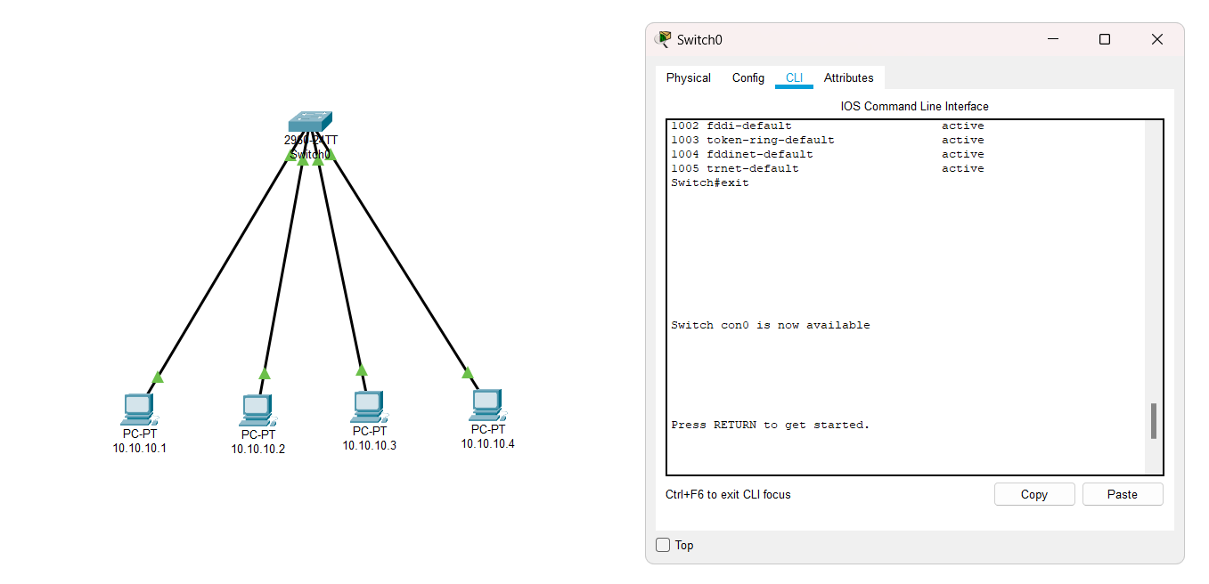

* Steps to create VLANs in packet tracer

Switch>enable

Switch# config t

Enter configuration commands, one per line. End with CNTL/Z.

Switch(config)#vlan 10

Switch(config-vlan)#name Ablock

Switch(config-vlan)#exit

Switch(config)#vlan 20

Switch(config-vlan)#name Cblock

Switch(config-vlan)#end

Switch#

%SYS-5-CONFIG_I: Configured from console by console

show vlan brief

Switch#config t

Enter configuration commands, one per line. End with CNTL/Z.

Switch(config)#interface range fa0/1-4

Switch(config-if-range)#switchport access vlan 10

Switch(config-if-range)#switchport mode access

Switch(config-if-range)#interface range fa0/5-10

Switch(config-if-range)#switchport access vlan 20

Switch(config-if-range)#switchport mode access

Switch(config-if-range)#end

Switch#

%SYS-5-CONFIG_I: Configured from console by console

show vlan brief

Switch#exit

